**Update Report – July 2024**

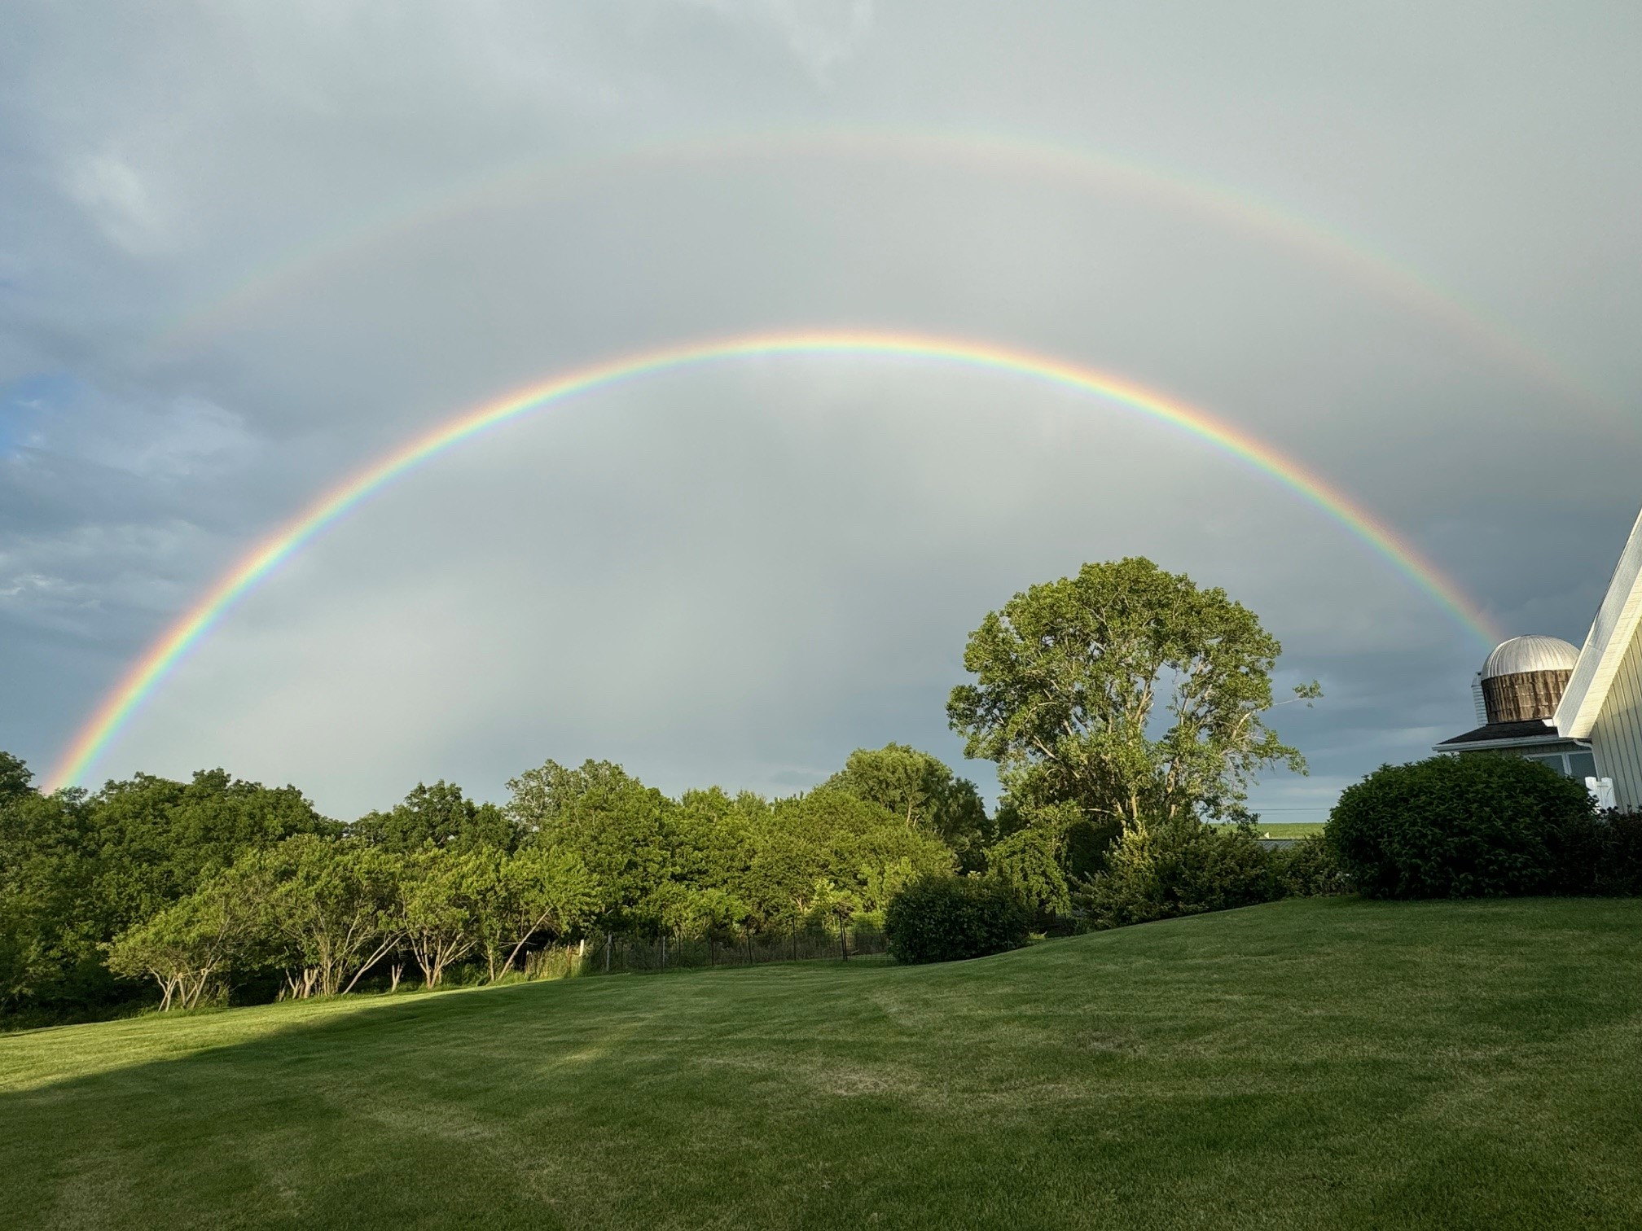

**Jackson County – Your HOME, Your FUTURE**

**PRESTON AND SABULA CATALYST GRANTS AWARDED!**

**PRESTON** - This project includes the complete construction of two one-bedroom apartments on the upper story of 172 W Gillet Street in Preston, Iowa. The space is vacant and unlivable. The previous owner had demolished the walls in anticipation of restoring the space into apartments but abandoned the idea when she was unable to receive adequate funding. City records show that this space has not been inhabited for at least 20 years.

This project is vital to Preston for many reasons. As populations continue to decline in rural areas, housing developers are hesitant to invest in new developments. As existing infrastructure continues to deteriorate, existing housing becomes no longer viable. It is essential to rural counties that existing infrastructure is maintained and improved and that quality-of-life investments are made to incent current residents to stay and new residents to relocate. Whether this entices current residents to stay or new residents to make Preston their home, it is a win for Preston and Jackson County. We need our residents to support local services, be a part of the workforce to support our existing businesses and be a part of our community to support one another.

**SABULA** – This project will include a lower-level commercial space which will include store front glass, an accompanying green space/common space and 2 upper floor residential units. When complete, the building will not only operate as a multi-functional building, but it will serve as a beautiful welcoming entrance

and cornerstone of the Sabula downtown area. The rehabilitation will utilize any and all salvageable resources and materials (beams, bricks, pillars, piping, etc) to ensure the buildings heritage and true existence remains, but also include modern and updated designs, features, and open air space/ concepts to attract visitors and tenants. This project is located at 405 Pearl St in Sabula, Iowa. This three-story building is one of the tallest downtown buildings with a great view of the river. It is just up the street from the successful 2020 Catalyst project at 415 Pearl Street. The building was originally built in 1880 and has the potential to continue to revitalize the beautiful Island City.

We have 36 public and private partners who are committed to funding our initiatives. We all should be grateful for their generosity because although they fund the JCEA, they also are investing in the future of each and every citizen and business who are proud to call Jackson Co their home because everything we do, no matter how big or small, benefits someone or some business. And every individual success is a success for the County. Special thanks to:

**Jackson County Board of Supervisors City of Maquoketa**

**City of Bellevue City of Preston**

**City of Miles City of Sabula**

**Maquoketa Municipal Electric Bellevue Municipal Electric**

**Maquoketa Valley EC Black Hills Energy**

**Alliant Energy Maquoketa State Bank**

**Bellevue State Bank US Bank**

**Fidelity Bank Clinton National Bank**

**DuTrac Bellevue BETA**

**Eastern Iowa Community College Precision Metal Works**

**Plastics Unlimited Jackson County Regional Hospital**

**Osterhaus Pharmacy Kunau Implement**

**Origin Design WHKS Engineering**

**Sonac Blue-9**

**Imagine the Possibilities Off Shore**

**Innovate 120 Water Street Partners**

**Community Foundation of Jackson Co Bellevue Chamber of Commerce**

**Maquoketa Chamber of Commerce ECIA**

**Dewitt Chamber and Development Company Mississippi Valley Workforce Dev**

**Iowa Workforce Development**

**Thank you to our**

**PARTNERS**

**When you become a partner with the JCEA you become part of a group of county and city government officials, along with most of our banks, utilities, and private businesses and industries who are vested in the growth of Jackson County. Any investment in the County is an investment in everyone who chooses to live, work or spend quality time in any one of our beautiful cities, amazing country sides or at any of the natural wonders in Jackson County. Our partners understand that their investment is repaid through the successes of our businesses, the improvements to our towns and the county, infrastructure, workforce, child care, and housing. We have so many opportunities for continued success. Let’s continue to work together.**

**JACKSON COUNTY – your HOME, your FUTURE!**

WORKFORCE OPPORTUNITIES

Ben Davison and I represent Jackson County on many different Boards and Commissions and attend regional and state trainings and seminars. We regularly attend the Maquoketa and Bellevue City Council meetings and monitor Preston City Council as well as Preston Growth and Development. We also review Jackson County and Sabula agendas and are in the process of contacting other cities to be on their agenda distribution list. We also represent Jackson County on Prosperity Eastern Iowa, Grant Wood Loop, Grant Wood Scenic Byway, Regional Planning Authority Policy Board, Jackson Transit Action Group, Mississippi Valley Workforce Business Committee, Mississippi Valley Workforce Finance Committee, Tri-State Economic Development Practitioners, Maquoketa Leadership Committee, Bellevue Leadership Committee, Green Space Planning Committee, Green Space Fundraising Committee, Maquoketa Department Executive Committee, Maquoketa Betterment Corp/Hometown Pride, Home Base Iowa – Jackson County Committee/Jackson County Veterans Board, Bellevue Downtown Incentive Review Committee, Maquoketa Downtown Incentive Review Committee, MIDAS, Wednesdays are possible Committee, Jackson County Local Emergency Preparedness and Planning Committee, Jackson County Comprehensive Plan Committee, Professional Developers of Iowa, Jackson County Energy District, Dev 2024 Conference, ECIA trainings and conferences, Mississippi Valley Workforce Board trainings, and we both completed our University of Oklahoma Economic Development Courses and received our certification.

**We**

**Are**

**I**

**N**

**V  
O  
L  
V  
E  
D**

Over 7,300 people will be retiring over the next 15 years. We have a little over 10,500 men and women in our workforce so losing 7,300 is pretty scary! If we look at it another way, that is 7,300 opportunities in the next 15 years for our youth and those who have moved away in search of other opportunities, to find the job that best meets their individual skills and abilities right here in Jackson County. We need to market ourselves. We need to highlight our employers showcasing the opportunities for successful futures right here. If Jackson County was your home and/or currently is your home, YOUR FUTURE IS HERE!

How do we get here? We get in the schools at an early age and start planting the seeds and sharing the stories of the opportunities right here, in the place they already call HOME! We continue to reinforce the message in every grade level. We highlight and share the success stories of people in all kinds of positions, making it personal and relatable. We understand that it is good to get different experiences and perspectives by pursuing additional educational opportunities or living in other cities, but ultimately, we want to draw everyone back to JACKSON COUNTY!

Individual Excellence is an individual’s pursuit of excellence of their unique skills and abilities. Societal culture needs to change to recognize that success is not defined by a salary or a job title. Success is each and every person doing the very best they can with their individual skills and abilities. When we become more accepting of each other, we reduce stress, we reduce the need for our kids to go somewhere else where they can hide in the masses and can instead stand tall and proud doing whatever they are good at. If we are going to reverse the population drain in Jackson County and replace those 7,300 men and women who will be retiring soon, we must change the mindset that a person isn’t successful unless they go somewhere else and be successful. SUCCESS is right here! You can be EXCELLENT here! Your FUTURE is here! Jackson County is your HOME, your FUTURE!

**Jackson County Child Care Survey update**

As you know from our previous announcement - Jackson County Economic Alliance, in partnership with the Community Foundation of Jackson County, has contracted with First Children’s Finance (FCF) to complete a child care study. The two-part study will include a child care market analysis and a strategic plan for child care. The first part, the market study, will focus on research and analysis on: the needs of local families and children, the current supply of regulated child care, parents’ current and preferred child care choices, effects on employers caused by lack of child care, and child care providers’ challenges. The report will include the key findings of the research and analysis, including a child care gap analysis quantifying how many children likely need care versus the number of spaces available.

The research being conducted by FCF included three surveys to gain insight from local employers, child care providers and parents. Employers were asked questions related to how child care impacts employee performance and time loss, and what supports related to child care they would be willing to provide to their employees in the future. Child care providers were asked about challenges they face today and how the community could better support child care providers. The parent survey focused on learning from working parents, as well as those who are not working due to child care challenges. Questions were focused on the challenges families face today and what will meet their future child care needs. The parent survey was designed for those that have children and are currently using or want to use child care in Jackson County, regardless of where they live.

After a number of marketing attempts, mailings to city halls and churches, phone calls, flyers, and newspaper ads, the surveys were finally closed the second week of July. In total there were 176 completed parent surveys, 22 employer surveys with ten employers with 50+ employees, and 6 child care provider surveys completed. In general First Children Finance said that it was a good response and indicative of survey response rates in general.

The survey results are being analyzed by First Children’s Finance and a report will be complete by the end of August.

The second part of the study is a strategic plan to address the challenges identified through the market study. The strategic plan will include a vision for the future of child care in Jackson County along with 5-year goals. Each goal will have detailed strategies and activities to provide a roadmap to achieve the desired outcomes.

This study was made possible in part through a Rural Child Care Market Study grant received by Jackson County Economic Alliance through the Empower Rural Iowa initiative, a program administered by the Center for Rural Revitalization, a division of Iowa Economic Development Authority. The Community Foundation of Jackson County also generously provided support for this study.

If you have questions or would like more information about this project, contact Kelley Brown, Director of the Jackson County Economic Alliance at [kelleybrown@thejcea.org](mailto:kelleybrown@thejcea.org).

**Business Retention and Expansion – because 80% of new jobs and capital investments come from existing businesses. Buy local. Support local. Celebrate local.**

**Jackson County - your HOME, your FUTURE!**

**Let’s meet. Let’s catch-up. Let’s see what we can do to support you. If we haven’t contacted you, please contact us: kelleybrown@thejcea.org**

**Special thanks to the businesses and building owners who have met with us these last few months:**

**TADA Meats SurgIT Prost Pub & Pizza Ken Anderson – Preston Pharmacy**

**Garman & Meade Accountants Brad Deery T.M. Woodworks Trevor Huizenga – old Treasure Trove (CHURCH) in Preston Sue Gossman Plastics Unlimited White Cap Kwik Star Dynamic Tube Taylor Casel- Voy 2 Theatres Dollar Fresh Tim Miller – TJ Construction**

**Business Retention and Expansion**

So far, we have received information from 14 Bellevue downtown business owners, 14 Maquoketa downtown business owners and 4 Preston downtown business owners. Our goal is to have a complete inventory of all the buildings, businesses, vacancies and your future plans. Please visit the survey by using the URL or by scanning the QR code below: <https://qfreeaccountssjc1.az1.qualtrics.com/jfe/form/SV_9TyLs3MqkWbNMYm>

**DOWNTOWN PROPERTY OWNER SURVEY**

**CATALYST GRANTS**

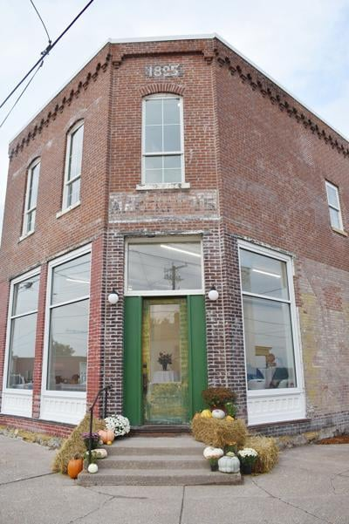

**CONTACT US TODAY FOR MORE INFORMATION ON THE CATALYST GRANTS.**

Ackerman Grocery store in Sabula converted into a street level commercial space with two upper-level living spaces. One will be an apartment and the other an Airbnb.

Our goal is to have every city in Jackson County benefit from a Catalyst Grant. For as little as $40,000 or so, your City can assist a current or future building owner in being a CATALYST for your community by improving their property. Catalyst grants award up to $100,000 so it can make a substantial difference. The project needs to be at least twice the cost of the grant request. A $100,000 grant request project would need to be estimated at a minimum of $200,000. Now is the time to start planning. Pre-applications will be accepted soon and are required to be approved and accepted before a final application can be submitted. Here is a link to more information or please call or email me at [kelleybrown@thejcea.org](mailto:kelleybrown@thejcea.org) or 515-802-1516.

<https://www.iowaeda.com/downtown-resource-center/community-catalyst/>

Project Hedron is a semiconductor manufacturer who will invest $40M in a facility and employ 74. JCEA received the Request for Information (RFI) on March 7th asking for a response by the EOB on the 8th. One of the qualifications was to be within 10 miles of an interstate. We asked for clarification given the site is less than a mile of HWY 61 which is only 36 miles from I80. This allowed us to meet the preliminary qualifications. We then moved on to the next round which was a comprehensive RFI due by noon on March 14th. Special thanks to Leallen Ehlers and Katie Bopes with EICC, Miranda Swafford and Mandy Tripp of Mississippi Valley Workforce, Christie Remley and Nik Schulte of MREC, Josh Boldt of City of Maquoketa and Amber Rodgers of IEDA for responding to quickly with necessary information to proceed forward. This is a multi-state RFI so the competition is tough. That said, we have affordable, land, utilities, workforce, organizations to train new employees, competitive incentives, and, of course, the culture and natural resources to draw people here and give them a reason to live and work in Jackson County. **UDPATE – we did receive notice that we were not selected for further consideration. We will keep trying!**

**Project Hedron RFI – Maquoketa Industrial Park**

BETA was established in 2009 to promote Tourism and Economic Development in Bellevue. In 2019 BETA entered into a development agreement with the City to purchase the Stamp Farm. The background was that there had been an industrial prospect who needed 30 acres of land, but there wasn’t any readily available. A proactive effort was made then to find and purchase land for availability in the future. Around 65 acres was purchased through a mutual agreement between the City, BETA and Bellevue Utilities. The plan was for the City to grant BETA the funds so the land could be purchased. BETA owns the property and can more easily sell parcels without going through the City’s vacation or property proceedings. Initially there was hope that a USDA grant could offset the cost for the utility extensions to the extent that it would make development more feasible. Unfortunately, the 2020 Census revealed that Bellevue no longer qualified for the USDA grant. That news along with COVID and the massive increase in costs, made the extension of utilities cost prohibitive. Options are now being considered for the sale of this land.

**Stamp Property – Bellevue Tourism and Economic Association**

**Future land development**

Discussions are continuing and contacts are being made with landowners in and around Bellevue who may be willing to sell their land for future development in Bellevue. Bellevue is in need of land for future residential, commercial and light-industrial.

**in Bellevue**

**O**

**OLD HOSPITAL SITE IN MAQUOKETA**

What once was viewed as a wonderful opportunity is now turning into a major challenge with no easy answers in site. In late 2021 the building and its 12.5 acre site were put out to bid. The winning bidder purchased the property for $500,000. The initial plans were to convert the building to senior housing and expand housing to the other portions of the property. Everything sounded great. Through the course of the last 2.5 years plans have changed, the building condition has greatly deteriorated and now the owner is sitting in jail with Federal charges. The Department of Justice “DOJ” contacted the City with plans to seize the property so it could be sold so that restitution could be made to the victims. Once the DOJ realized the current condition of the property, they decided not to seize the property. What does all this mean? We don’t really know other than the current owner obviously won’t be doing anything with the building or the land. It’s a hefty burden being left to the City because there is asbestos that needs to be removed and two underground storage tanks. Not to mention the building itself has now deteriorated to the extent that it will just need to be demolished and hauled away. In the long run it will be 12.5 acres of land in a residential and multi-family area that could be, as it was originally planned to be, a large complex of badly needed senior housing. But, in the meantime, there are a lot of hurdles to jump through and at a large cost.

**Maquoketa Urban Revitalization Program**

Maquoketa has an urban revitalization program that encourages making those necessary maintenance repairs and improvements to your property. It also encourages the construction of new homes and multi-family dwellings. This plan covers all land that is currently annexed in the City. The improvements must increase the overall value of the property by 10%. The benefits for your investment include a 100% property tax exemption for the first $75,000 of valuation of your property. As stated above, this includes the construction of new homes as well. All new homes get 100% abatement on the first $75,000 of valuation of your home for 5 years!! A residential property with three or more separate dwelling units is eligible to receive property tax abatement for 10 years with the first year abating 80% of your value decreasing over the following 9 years.

Ben chairs the Maquoketa Greenspace Planning Committee and is the Vice-Chair of the Maquoketa Betterment and Hometown Pride Committee. The plans have been finalized other than some smaller details and fundraising has been outstanding. Here is more information for how you can be a part of this success.

<https://maquoketagreenspace.org/>

**Maquoketa Greenspace**

**Fundraising**

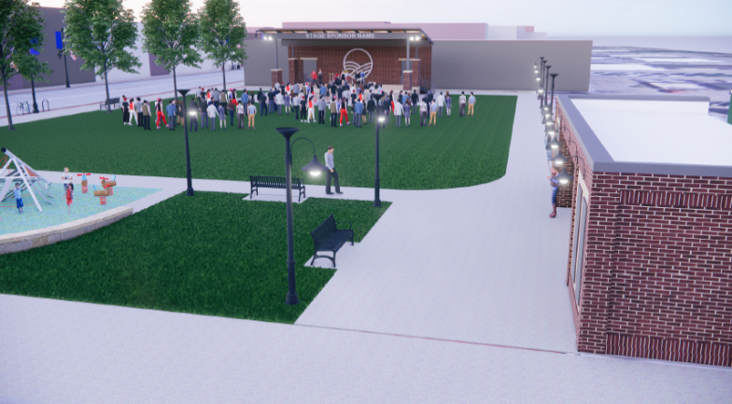

**Downtown Incentive Programs**

Bellevue, Maquoketa and Preston all have downtown incentive programs that will pay up to a shared amount for improvements in the following areas: Acquisition, Signage, Consultant Assistance, Façade, Commercial Interior, Upper Story Renovation, Conversion of 1st floor from residential to commercial. Cities finance these programs through the use of TIF dollars. TIF means tax increment financing. TIF is used to pay or rebate funds to developers and property owners for improvements and new development resulting in an increase in valuation. The increase in valuation means an increase in tax revenue for the City, County, School District, Community College, County Hospital and other misc items. An increase in valuations is needed for a City to stay financially healthy and to be able to provide the necessary services and cultural amenities people need to feel good about where they live. I encourage all cities to consider putting together an urban renewal plan for your city and developing a downtown incentive program. A healthy downtown promotes a healthy city! EVERYONE WINS!!!

JCEA receives a few calls and visits each month regarding start-up businesses or business expansions and relocations. It’s always a delicate balance in situations where a national franchise is looking to locate in an area where there is already another national franchise competitor in the area. This also pertains to businesses on a smaller scale where there is already a business with that specialty in our area. We do our best to show opportunities where they are available at all levels and encourage open communication. In general, all of the COVID funding where cash was available for new businesses is gone. There are low interest loans and support and coaching programs available that assist small business owners in getting started and don’t forget – Wednesdays are possible.

**Small business development**

Wednesdays are possible is a monthly conversation about entrepreneurship held the first Wednesday of every month either at Innovate 120 or at various locations throughout the county. Each month an entrepreneur is interviewed in an informal fashion and whomever attends gets the benefit of hearing their story. It’s a great way to learn and support each other. Come join us on the first Wednesday of the month at 4:30. Check the Innovate 120 FB page for the upcoming speaker and location of the event!

**Wednesdays are possible**

**Tri-State Developers Meetings**

Economic Development Directors from Illinois, Wisconsin and Iowa get together bi-monthly to meet and talk about regional/national economic development challenges. Every area is fighting the same challenges: housing, workforce, and childcare. Plateville is addressing the workforce challenge by “adopting” and financing the relocation of immigrant families. Overall there are no easy answers and they all come at a high-financial cost.

The award of $350,000 to Jackson County Emergency Management to establish an EOC was a huge success for the County. An EOC is an Emergency Operation Center established to be a communication and command center in the event of an emergency. Currently the equipment is being ordered. The EOC will be located in the new Jackson County jail which is anticipated to be completed yet this year.

**Jackson County EOC**

ECIA obtained a DRA grant to assist counties and Travel Dubuque whereby Travel Dubuque will market and highlight the tourism attractions in all our counties. We have a page in the Travel Dubuque guide and will have links and QR codes to take tourists websites and FB pages that will showcase the area amenities! Our businesses need people so let’s get them into Jackson County by showing them what they are missing!

**Travel Dubuque**

**Grants and funding opportunities**

Every month ECIA sends out a list of available grants and funding opportunities. If you are not familiar with ECIA, please click on this link and see all that ECIA has to offer. <https://www.ecia.org/> ECIA is a wonderful partner to us. We coordinate a lot of projects and grant opportunities with ECIA. <https://www.ecia.org/about_ecia/sign_up.php> is the link you can use to sign up for grant opportunities or their bi-monthly newsletter.

I (Kelley) have more than 26 years of city government experience as a city administrator and a city clerk. I am also a government finance geek. I am ready and willing to assist in budget questions issues, TIF, employment interviewing, hiring, and just general support. I have been actively assisting Bellevue, Preston and Sabula. As you work through budget planning for the future as well, we are here to help. ( I even learn and understand HF 718 – ha!)

**City Staff assistance**

**The future**

**Your current position in life doesn’t define how far you can go, it only defines where you start. If you don’t like this chapter in your life, turn the page and start a new one.**

**The future is yours to create! We can help!**

**THANK YOU FOR YOUR CONTINUED PARTNERSHIPS**

**We sincerely appreciate your time, passion, and energy!**

**MAY THE BEAUTY OF JACKSON COUNTY WELCOME YOU HOME.**

**Director Kelley Brown** [**kelleybrown@thejcea.org**](mailto:kelleybrown@thejcea.org) **515-802-1516**

**Asst Director Ben Davison** [**Bendavison@thejcea.org**](mailto:Bendavison@thejcea.org) **563-357-5631**